**SB FOOD APPLICATION Using MERN Stack**

***Screenshots of Installation and Executions***

**1. PRE-REQUISITES :**

Here are the key prerequisites for developing a full-stack application using Node.js, Express.js, MongoDB, React.js:

* **Node.js and npm:**

Node.js is a powerful JavaScript runtime environment that allows you to run JavaScript code on the server-side. It provides a scalable and efficient platform for building network applications. Install Node.js and npm on your development machine, as they are required to run JavaScript on the server-side.

# Download: <https://nodejs.org/en/download/>

Installation instructions: <https://nodejs.org/en/download/package-manager/>Run **“npm init”** to get default dependencies

* **Express.js:**

Express.js is a fast and minimalist web application framework for Node.js. It simplifies the process of creating robust APIs and web applications, offering features like routing, middleware support, and modular architecture. Install Express.js, a web application framework for Node.js, which handles server-side routing, middleware, and API development.

Installation: Open your command prompt or terminal and run the following command: **npm install express**

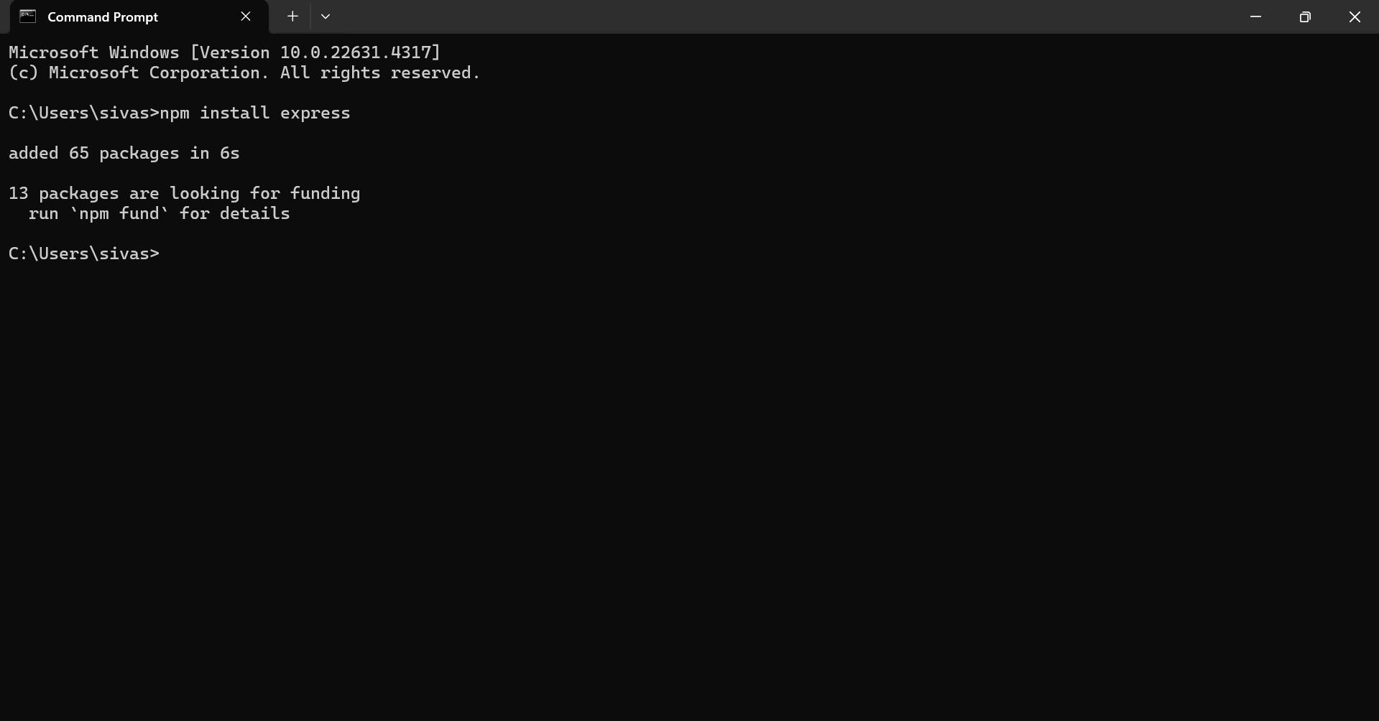

* **MongoDB:**

MongoDB is a flexible and scalable NoSQL database that stores data in a JSON-like format. It provides high performance, horizontal scalability, and seamless integration with Node.js, making it ideal for handling large amounts of structured and unstructured data.

Set up a MongoDB database to store your application's data.

Download: <https://www.mongodb.com/try/download/community>

# Installation instructions: <https://docs.mongodb.com/manual/installation/>

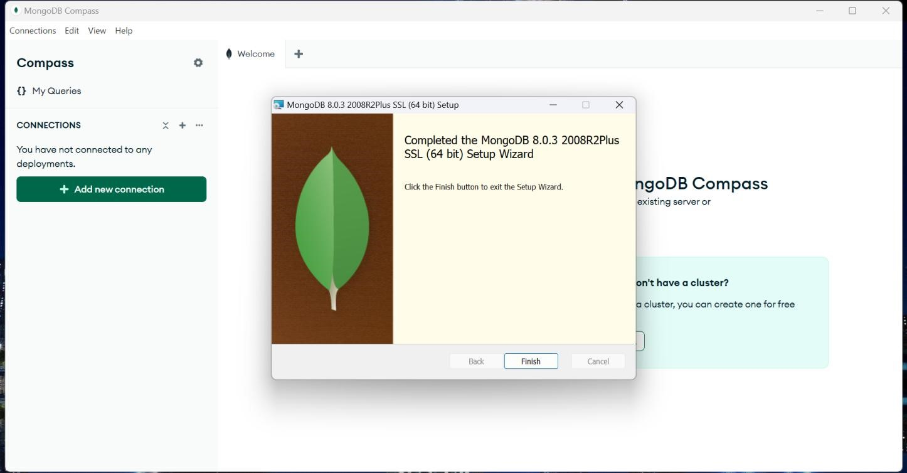

* **React.js:**

React.js is a popular JavaScript library for building user interfaces. It enables developers to create interactive and reusable UI components, making it easier to build dynamic and responsive web applications.

Install React.js, a JavaScript library for building user interfaces.

Follow the installation guide: <https://reactjs.org/docs/create-a-new-react-app.html>

* **HTML, CSS, and JavaScript**:

Basic knowledge of HTML for creating the structure of your app, CSS for styling, and

JavaScript for client-side interactivity is essential.

* **Database Connectivity**:

Use a MongoDB driver or an Object-Document Mapping (ODM) library like Mongoose to connect your Node.js server with the MongoDB database and perform CRUD (Create, Read, Update, Delete) operations.

* **Front-end Framework**:

Utilize React.js to build the user-facing part of the application, including entering booking room, status of the booking, and user interfaces for the admin dashboard. For making better UI we have also used some libraries like material UI and boostrap.

Install the required dependencies by running the following commands:

**cd frontend || npm install cd ../backend || npm install Start the Development Server:**

* To start the development server, execute the following command:

npm start

The installation is successfully installed and set up the SB FOOD APPLICATION on your local machine. You can now proceed with further customization, development, and testing as needed.

* 1. **SCREENSHOTS :**

User login page

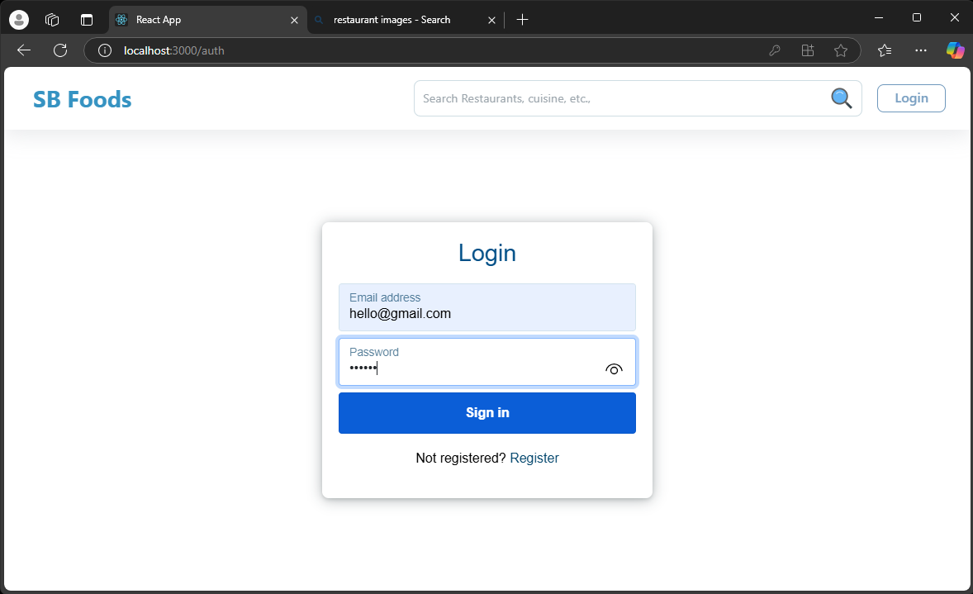

User register page:

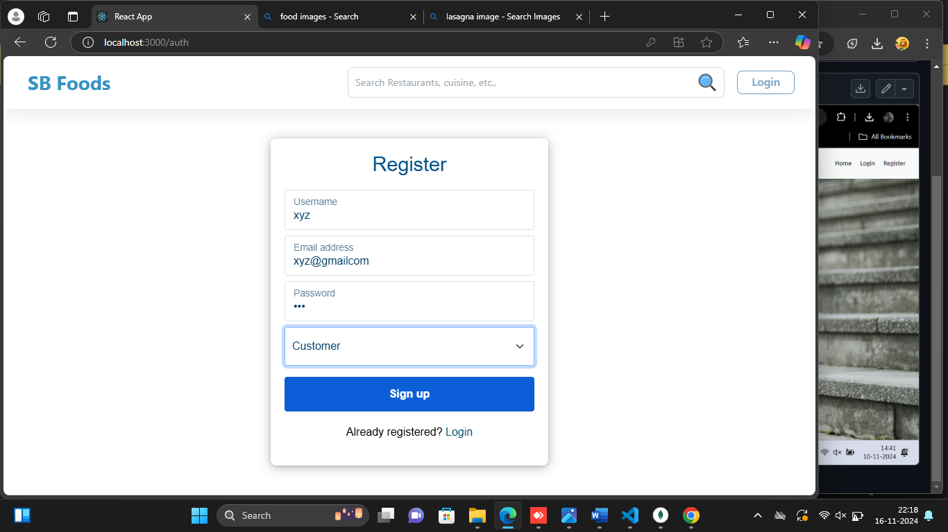

Admin home page:

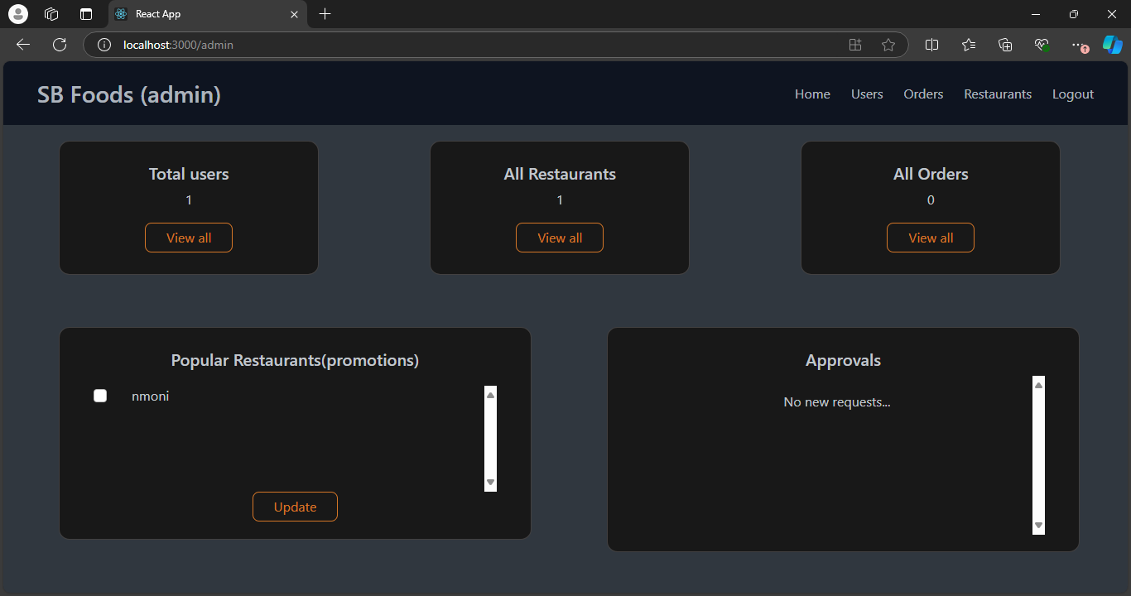

New item added in list:

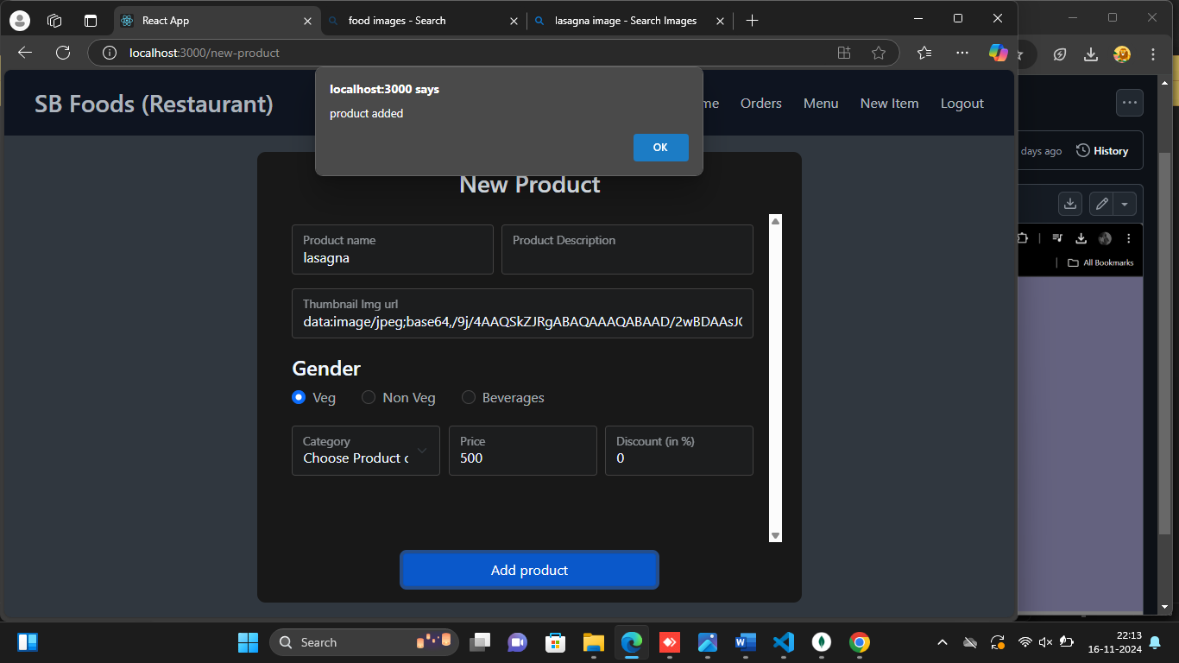

Users of application:

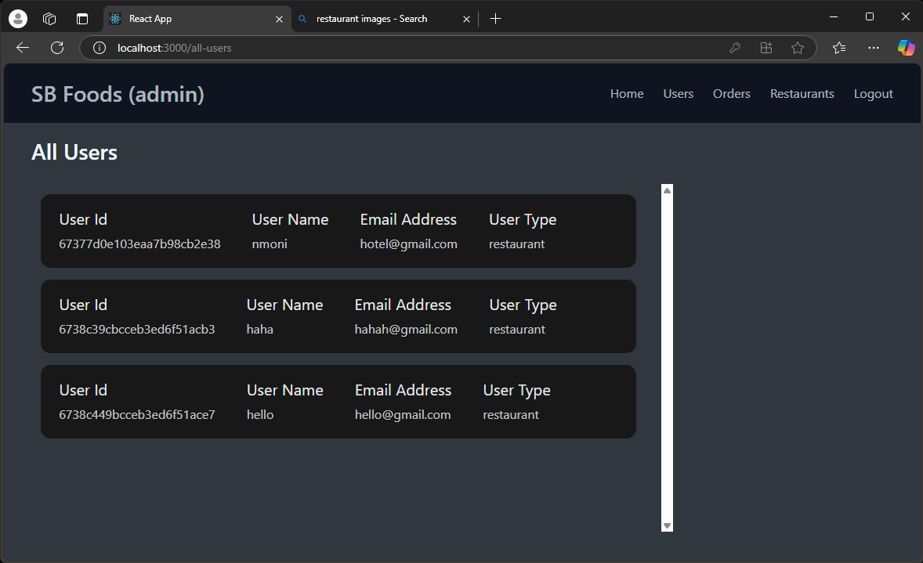

Items added to homepage:

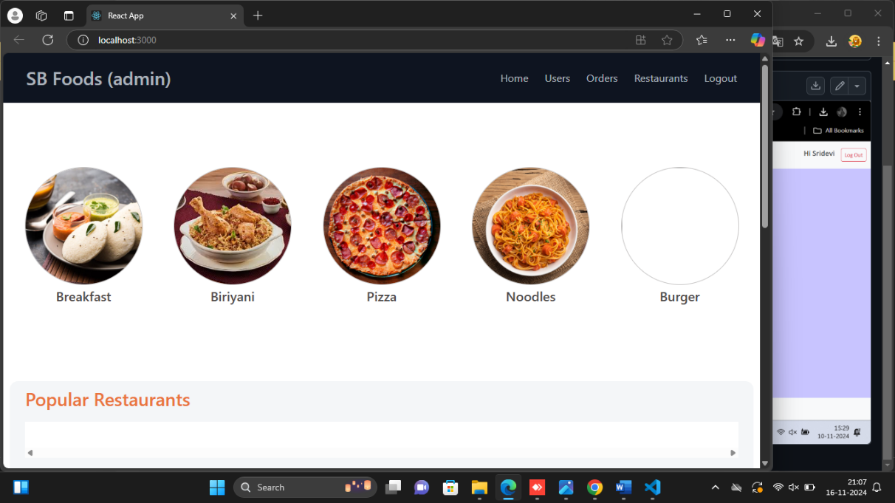

User cart items:

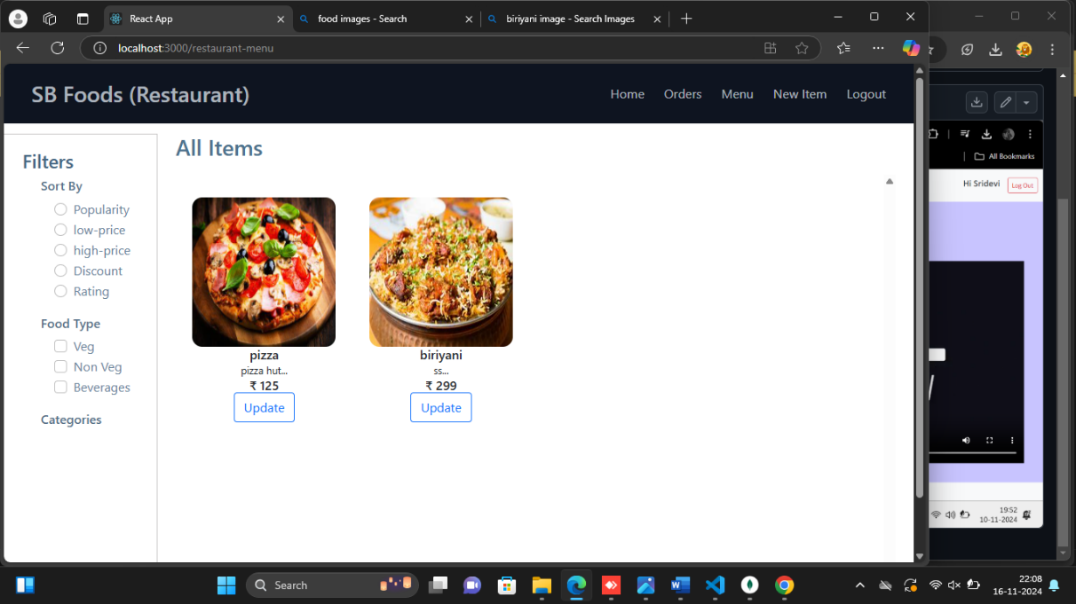

DATABASE DETAILS:

Database:

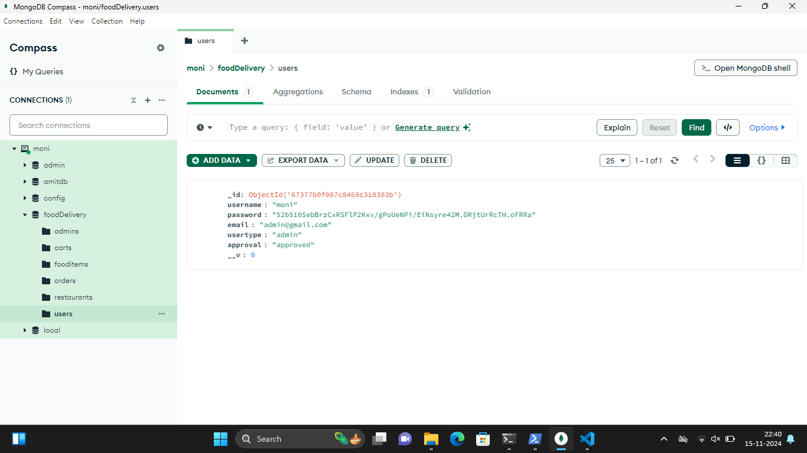

Food item database:

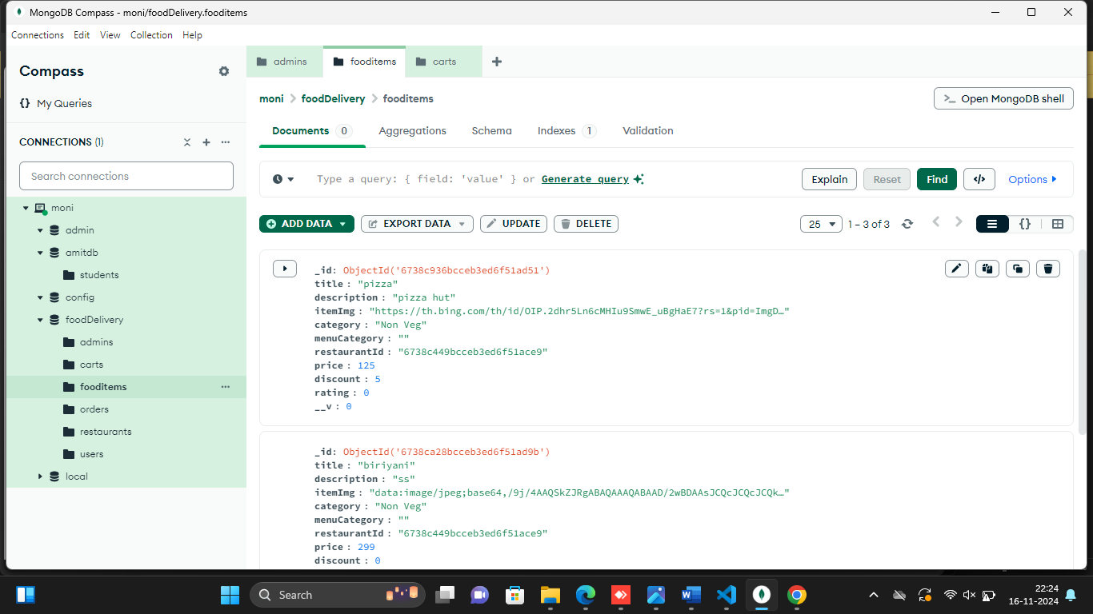

User database:

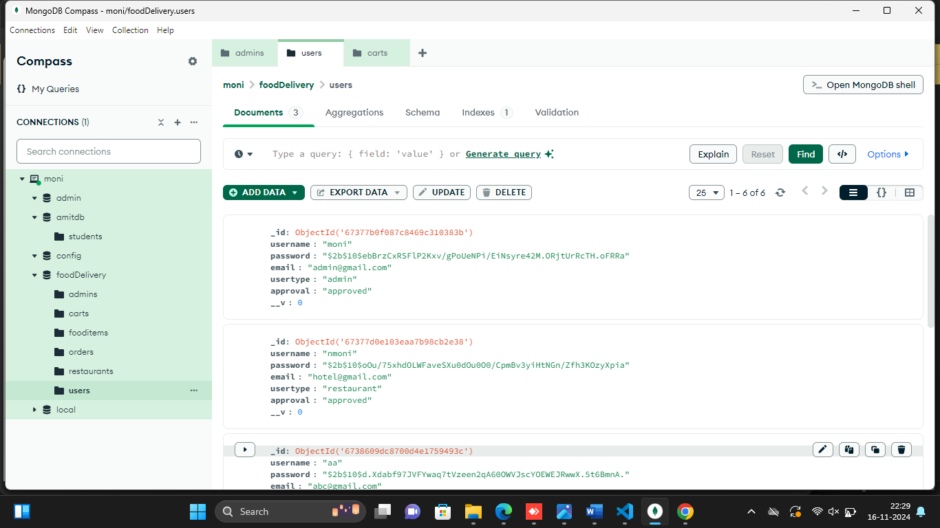

Restaurant database:

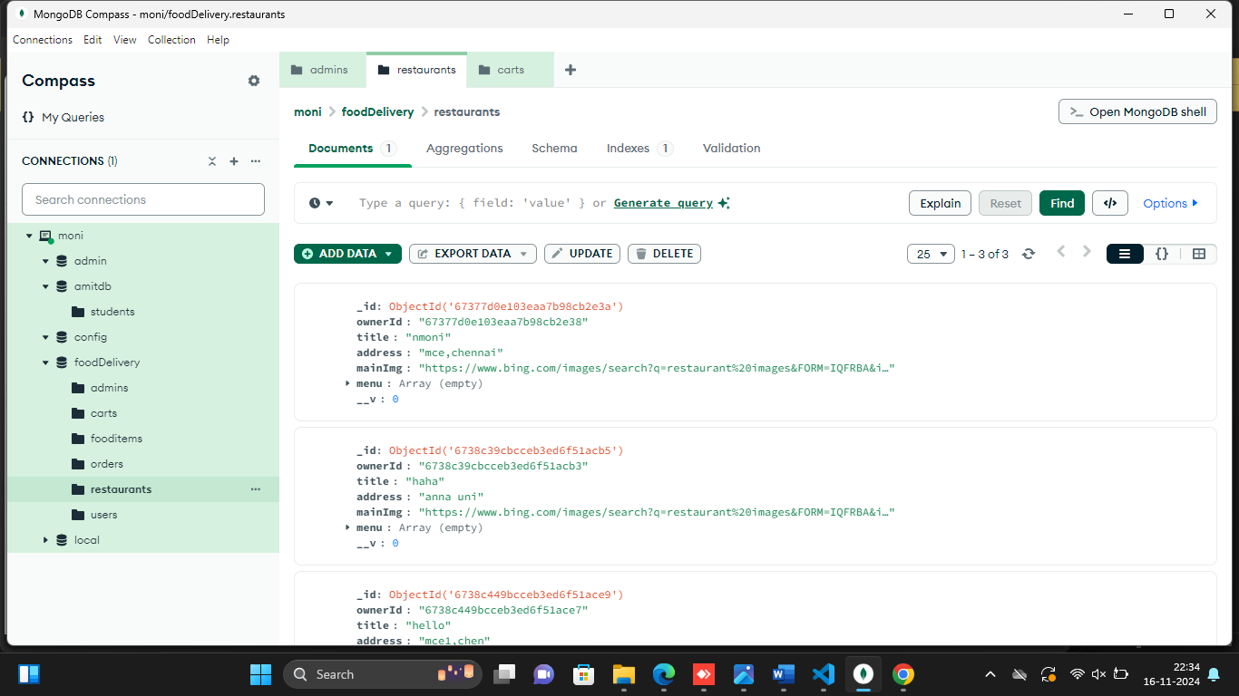

Collection database:

